Viola Kones face detection algorithm:

Look at error rate. Weak classifier has error rate around 0.5. string classifier has minimum error rate, ideally around 0.1.

Idea of boosting, is that with each iteration of testing, you weight the samples with the most error heavy, and the samples with the least error lightly. Whether that be a binary error result (0 or 1), or what.

Decision tree stumps, what you can do with one test. Instead of dividing data into homogeneous groups.

-Haar features:

Four basic types. Easy to calculate. White areas are subtracted from the black ones. A special representation of the sample called the integral image makes feature extracition faster

-Integral image: Compute partial sum of image up to a pixel. Use four points at the corner of a region to calculate its sum.

-Adaboost:

algorithm which helps find only the important features among the 160k+ features. After these features are found, a weight combination of all the featuers is used in evaluating and deciding if any given window has a face or not. Each of these selected features are considered okay to be included if they can at least perform better than random guessing (detects more than 50% of the cases). Each of these features are called weak classifiers, the linear combination of these weak classifier is called a strong classifier.

1) starts with a uniform distribution of weights over training examples

2) selects the classifier with the lowest weighted error

3) increase the weights on the training examples that were misclassified. Decrease the weights on the examples that were correctly classified

4) repeat (goto 2)

5) finally make a linear combination of the weak classifiers obtained at all iterations

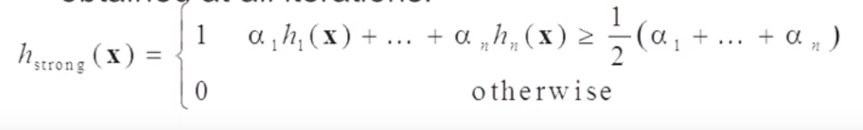

Gaussian weak classifier, find threshold, find error rate, all classifiers with lowest error rates are added to final strong classifier. Faces and non faces each have a Gaussian bell curve, find the middle of the overlapping region between each curve.

Boosting. Also known as boosting. Focus each following classifier on the err

-Cacading

Face Tracking algorithm:

-Mean shift:

-Histogram backprojection:

-Continuous Adaptive Mean shift (camshfit):

brain tries to identify features, thresholds in both the correct pictures and the incorrect pictures. store everything in file